Daily Stand-Up Meeting
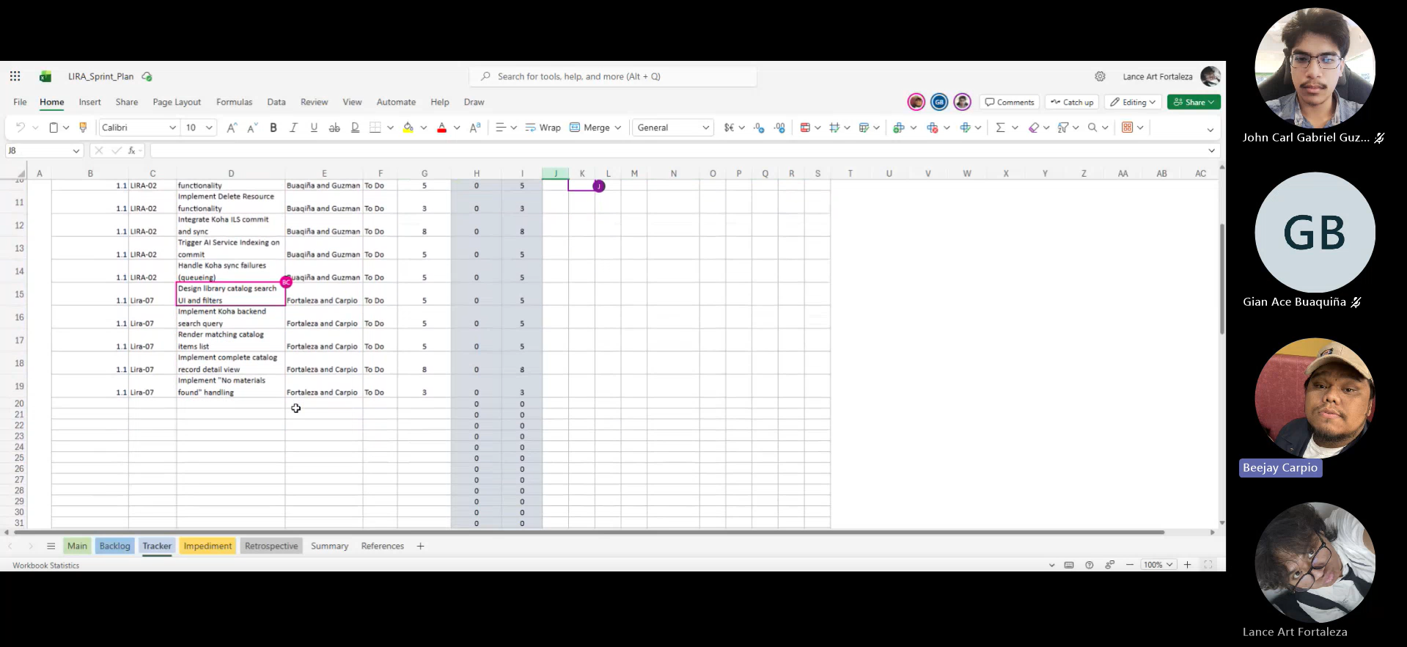

Daily Stand-Up Meeting
Minutes of meeting
Date: 09/16/2026
Meeting Called By: Cache Flow
Meeting Link: Daily Stand-Up Meeting-20260916_205831-Meeting Recording.mp4

Attendees
Gian Ace Buaquiña
Beejay A. Carpio
Lance Art P. Fortaleza
John Carl Gabriel Guzman

Summary
We reviewed the progress on the backlog and project setup. For deployment, Proxmox will be used as required for APC client projects. We need to know the catalog because it was needed across the librarian, student, and faculty sides, We will meet sir Jojo tomorrow for clarification.

What we did yesterday:
The team created the new GitHub repository and started building the student side UI first.

What we did today:
The team completed the student side dashboard UI and book catalog listing layout, populated the sample database, enabled and tested the functionality of dashboard buttons.

